Test Case: tc006_SPX_Dev5_Crear_Requisicion_Spot_Tipo_Cobro_Proyect_Urgent
Step 1 - Enter username and password and click to button Enter: Credentials Entered
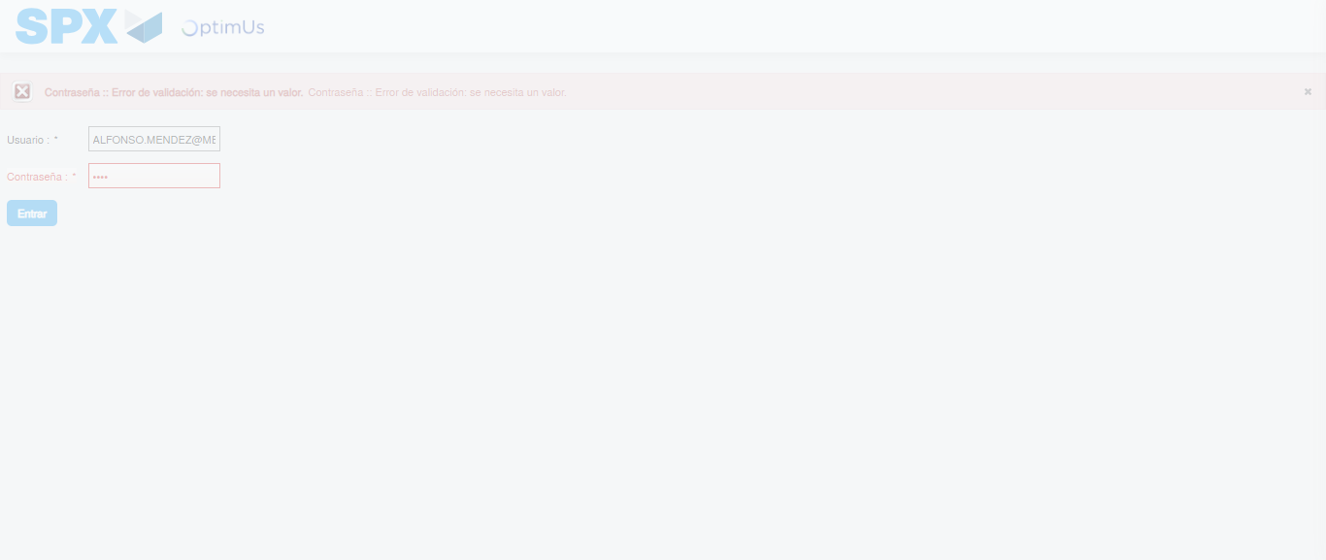Image file-name: QC_Testing-tc006_SPX_Dev5_Crear_Requisicion_Spot_Tipo_Cobro_Proyect_Urgent-1783362216664

Step 2 - Select to UEN and Access to Spot Buy Requisitions : UEN Correctly selected and Correct access
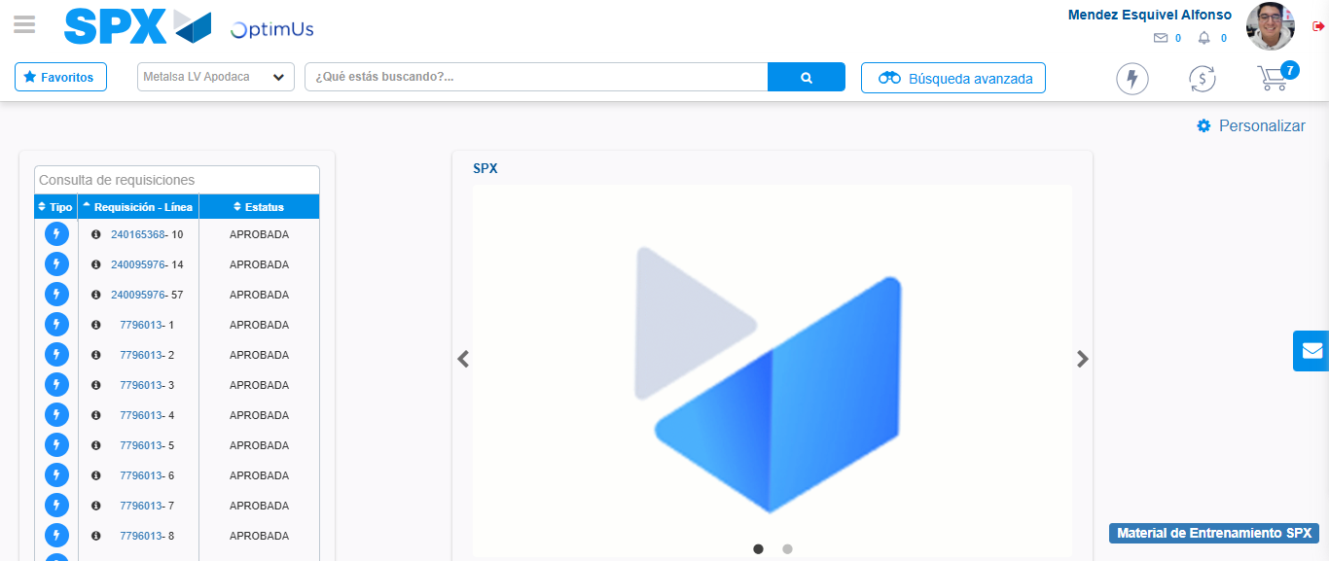Image file-name: QC_Testing-tc006_SPX_Dev5_Crear_Requisicion_Spot_Tipo_Cobro_Proyect_Urgent-1783362242137

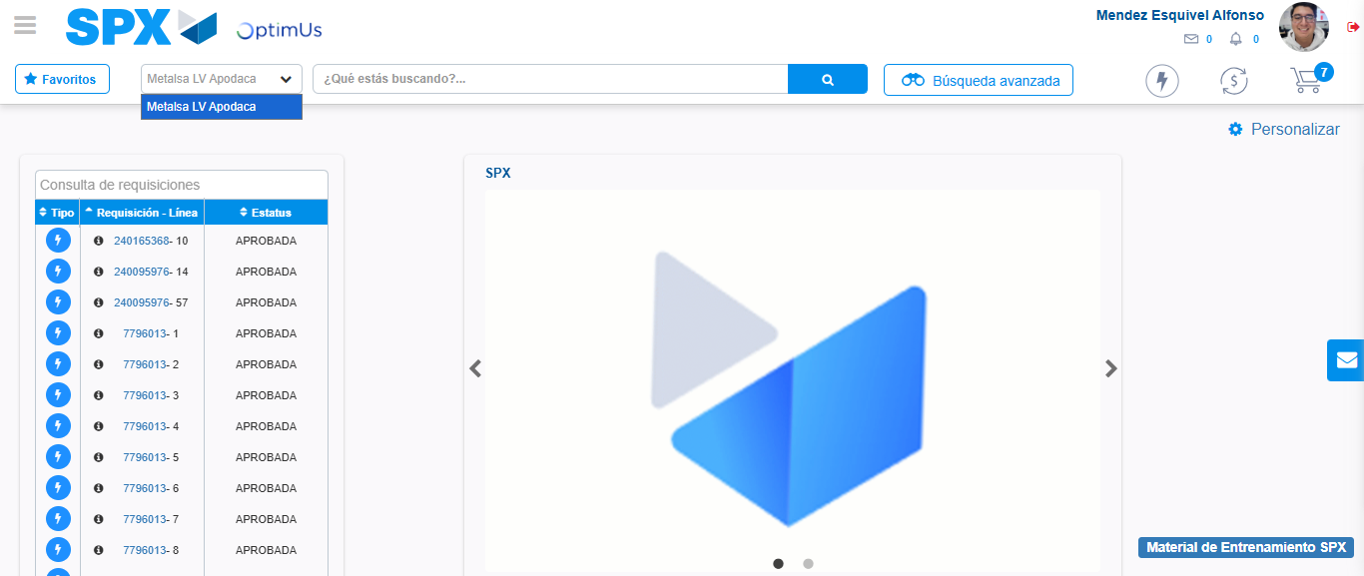Image file-name: QC_Testing-tc006_SPX_Dev5_Crear_Requisicion_Spot_Tipo_Cobro_Proyect_Urgent-1783362244915

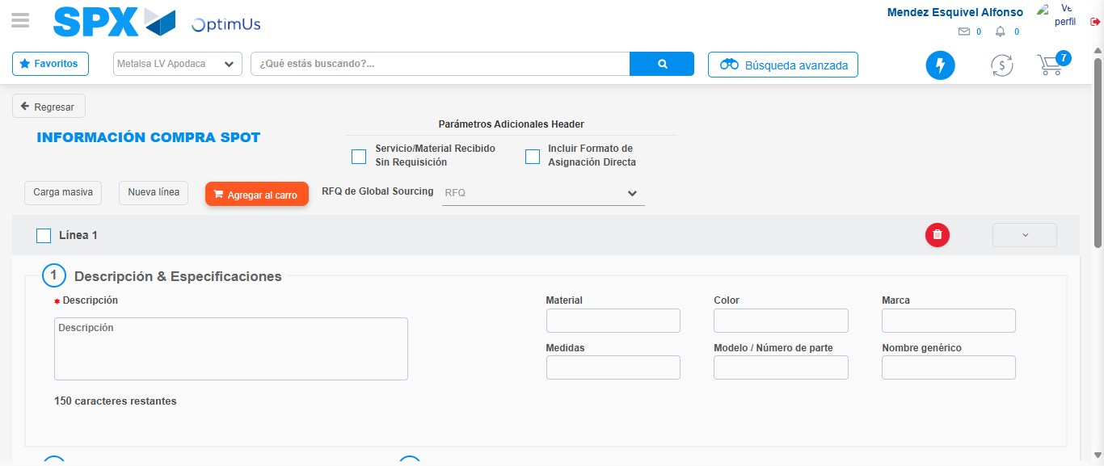Image file-name: QC_Testing-tc006_SPX_Dev5_Crear_Requisicion_Spot_Tipo_Cobro_Proyect_Urgent-1783362268101

Step 3 - Data Capture Spot Buy Requisition: Data captured correctly
Image file-name: QC_Testing-tc006_SPX_Dev5_Crear_Requisicion_Spot_Tipo_Cobro_Proyect_Urgent-1783362268409

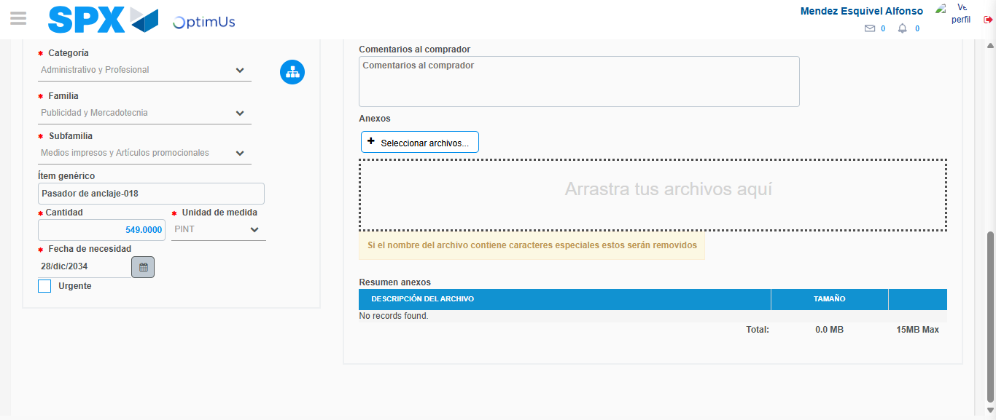Image file-name: QC_Testing-tc006_SPX_Dev5_Crear_Requisicion_Spot_Tipo_Cobro_Proyect_Urgent-1783362280925

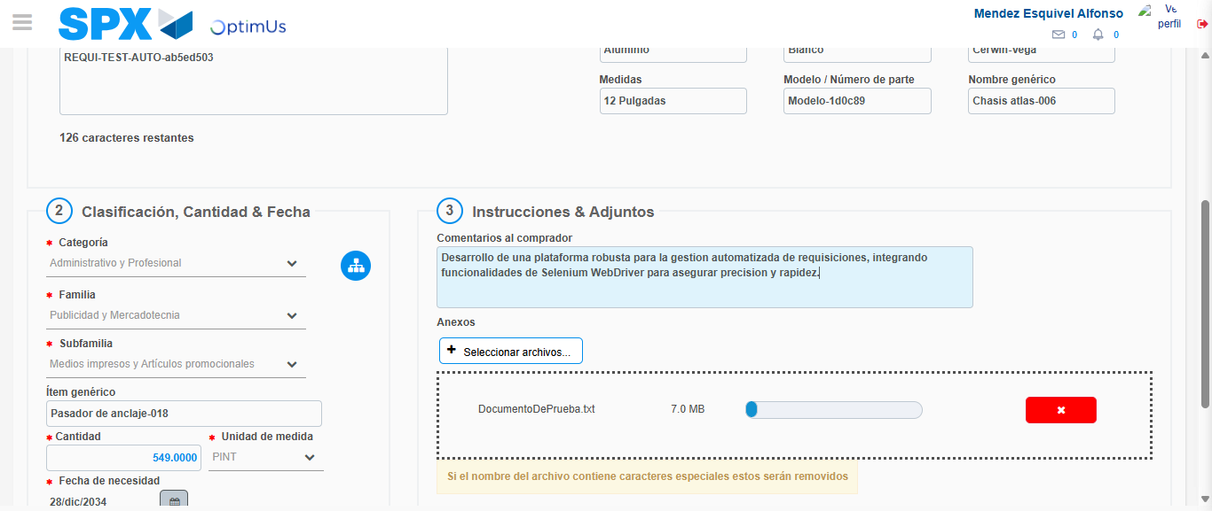Image file-name: QC_Testing-tc006_SPX_Dev5_Crear_Requisicion_Spot_Tipo_Cobro_Proyect_Urgent-1783362281870

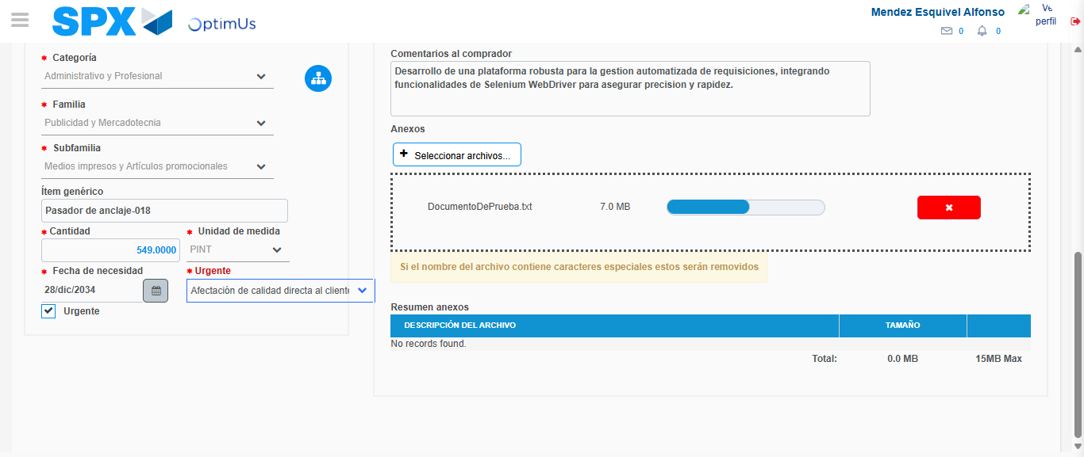Image file-name: QC_Testing-tc006_SPX_Dev5_Crear_Requisicion_Spot_Tipo_Cobro_Proyect_Urgent-1783362285855

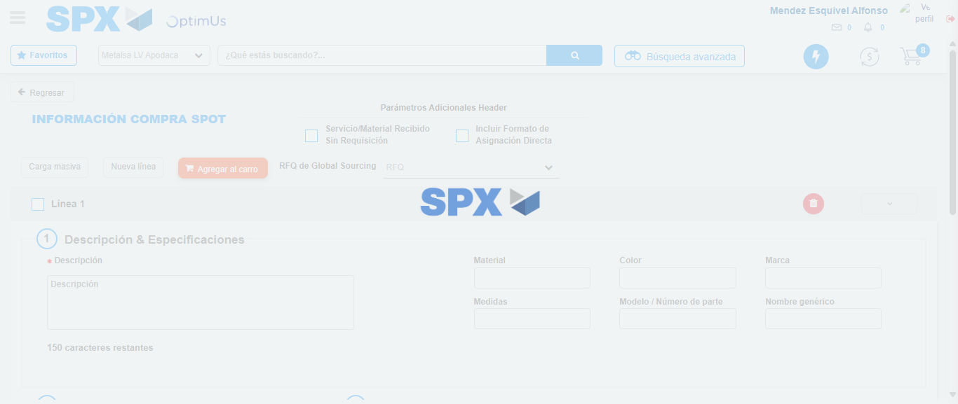Image file-name: QC_Testing-tc006_SPX_Dev5_Crear_Requisicion_Spot_Tipo_Cobro_Proyect_Urgent-1783362287012

Step 7 - Return to Main Page SPX : Return to Main Page SPX
Image file-name: QC_Testing-tc006_SPX_Dev5_Crear_Requisicion_Spot_Tipo_Cobro_Proyect_Urgent-1783362242137

Image file-name: QC_Testing-tc006_SPX_Dev5_Crear_Requisicion_Spot_Tipo_Cobro_Proyect_Urgent-1783362244915

Image file-name: QC_Testing-tc006_SPX_Dev5_Crear_Requisicion_Spot_Tipo_Cobro_Proyect_Urgent-1783362268101

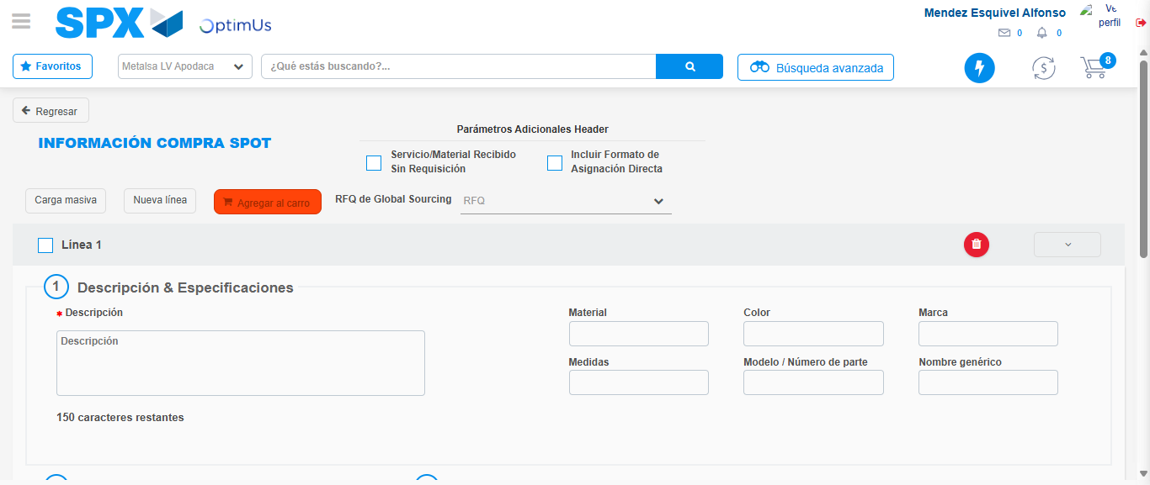Image file-name: QC_Testing-tc006_SPX_Dev5_Crear_Requisicion_Spot_Tipo_Cobro_Proyect_Urgent-1783362289280

Image file-name: QC_Testing-tc006_SPX_Dev5_Crear_Requisicion_Spot_Tipo_Cobro_Proyect_Urgent-1783362289479

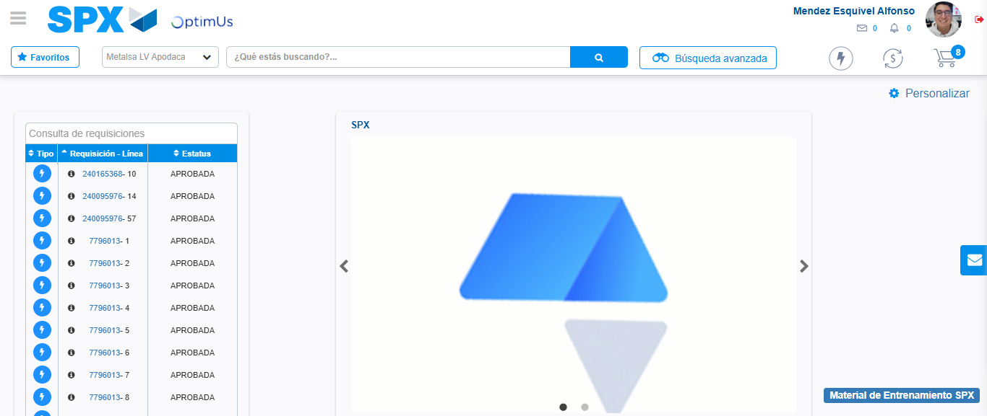Image file-name: QC_Testing-tc006_SPX_Dev5_Crear_Requisicion_Spot_Tipo_Cobro_Proyect_Urgent-1783362310853

Step 8 - Log Out : Log Out SPX
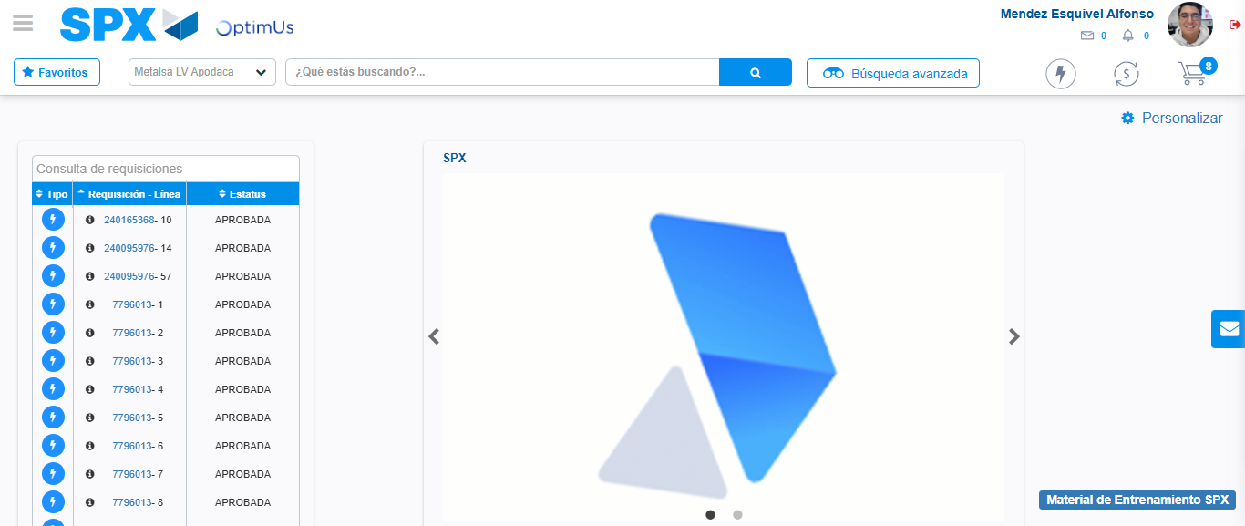Image file-name: QC_Testing-tc006_SPX_Dev5_Crear_Requisicion_Spot_Tipo_Cobro_Proyect_Urgent-1783362311120

